**Department of Electronics and Telecommunication Engineering**

**Module wise University Questions**

**(First Half of 2023)**

**Class/Sem: BE/VIII Branch: EXTC**

**Subject: OCN**

**Module 6: Network Design and Management**

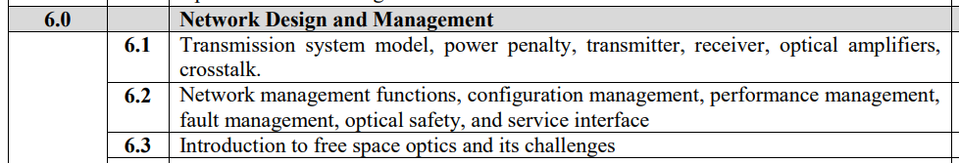

**May 2019**

1. What is optical amplifier? Explain in brief its different types [10]
2. Write short note on: cross talk in optical system [05]
3. Write short note on: Wavelength stabilization [05]
4. Write short note on: Network management functions [05]
5. Write short note on: optical safety [10]

**Dec 2018**

1. Write short note on: cross talk in optical system [10]
2. Write short note on: Wavelength stabilization [10]
3. Write short note on: Network management functions [10]
4. Write short note on: optical safety [10]

**May 2018**

1. Explain important network management functions to the operation of the network. [10]

**Dec 2017**

1. Derive an expression of power penalty with impairment and without impairment [10]
2. Write short note on: cross talk [10]
3. Write short note on: optical safety [10]

**May 2017**

1. Write short note on: cross talk [10]
2. Write short note on: Fault management. [10]
3. Write short note on: optical safety [10]

**Dec 2016**

1. Derive an expression of power penalty with impairment and without impairment [07]
2. Define cross talk. What are the types of crosstalk in optical transmission system? [05]
3. Comment on need of wavelength stabilization [04]
4. Explain important network management functions to the operation of the network. [08]

**May 2016**

1. Short Note on: Optical Safety [07]
2. Short Note: a. Transmission system model[05]
3. Explain different functions of network management.[05]
4. Give the details of network management in a typical optical network[10]
5. Comment on optical safety communication network [05]

**Dec 2015**

1. What is optical safety [05]